# 

**COLLEGE OF COMPUTING AND INFORMATION SCIENCE**

**COURSE: BACHELOR OF SCIENCE IN SOFTWARE ENGINEERING**

**COURSE UNIT:** **USER INTERFACE DESIGN**

**NAME: LUTALO ALLAN**

**REG NO: 22/U/3330/PS**

**GITHUB LINK:** [**https://github.com/Liven-Allan/FigmaProject**](https://github.com/Liven-Allan/FigmaProject)

**FIGMA LINK:** [**https://www.figma.com/design/dkhhEcTk4eAEdCxrMVxFGu/test_work?node-id=0-1&node-type=canvas&t=MgelRqHTgo3er3Gd-0**](https://www.figma.com/design/dkhhEcTk4eAEdCxrMVxFGu/test_work?node-id=0-1&node-type=canvas&t=MgelRqHTgo3er3Gd-0)

# Figma Report on “Fight Like A Champion” User Interface Design

## Overview

The "Fight Like a Champion" app is designed as a workout platform tailored for users interested in boxing and fitness. The app provides a streamlined and interactive experience for selecting workout types, customizing routines, and tracking progress. It includes features such as welcome screens, workout selection, and real-time workout tracking.

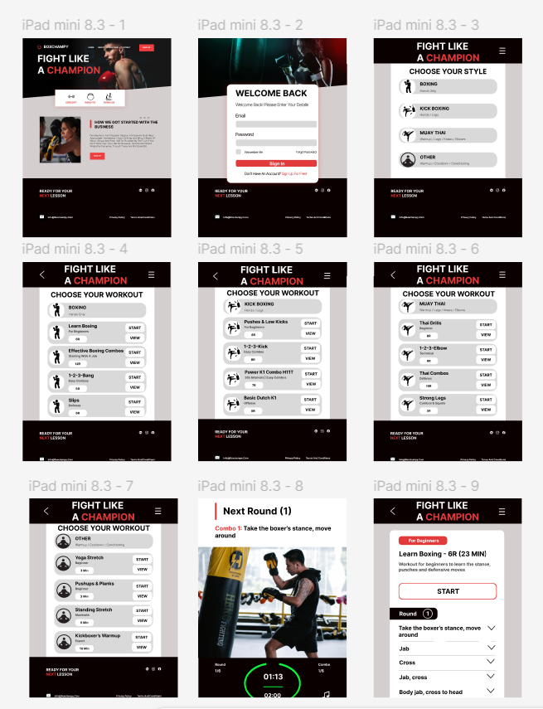

## Design Details

* **Welcome & Login (Frames 1-2):**Users are greeted with a visually striking welcome screen emphasizing the app’s boxing theme.  
  The login page features a clean and user-friendly interface for returning users to access their profiles quickly.
* **Workout Selection** (Frames 3-7):  
  Users can choose a workout type based on their fitness goals, with options for strength, cardio, or specific boxing drills.  
  Each workout option displays essential information, including difficulty level, time duration, and targeted muscle groups.
* **Workout Customization** (Frames 9):  
  Users can customize their workout session, selecting rounds, rest time, and exercise intensity.  
  The interface is designed to make customization simple and intuitive, with icons and dropdowns for easy navigation.
* **Active Workout Mode** (Frame 8):  
  During workouts, the app displays an interactive timer, real-time stats, and progress indicators to keep users engaged and on track.  
  A large visual element shows the next exercise in the sequence, providing clear guidance without distraction.

Design Style  
The app utilizes a dark theme with bold typography and red accents to convey energy and strength, aligning with the boxing aesthetic. The design prioritizes readability and ease of use, ensuring that users can navigate seamlessly through various sections.

User Experience Highlights

* The app’s layout and design elements support quick decision-making, essential for workout applications.
* Interactive elements, such as the workout timer and real-time feedback, enhance engagement and motivation.
* Clear progress indicators and customization options allow users to tailor workouts to their fitness levels.

## Conclusion

This Figma design effectively captures the essence of a boxing-focused workout app, combining functionality with a visually appealing and intuitive interface. It is well-suited for fitness enthusiasts who want a structured yet customizable workout experience.